**Hello World RESTful Web Service**

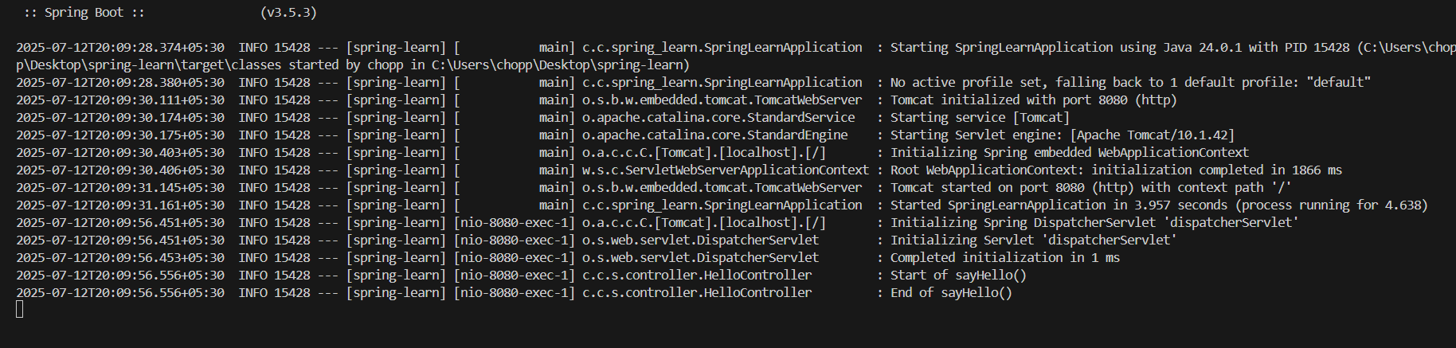

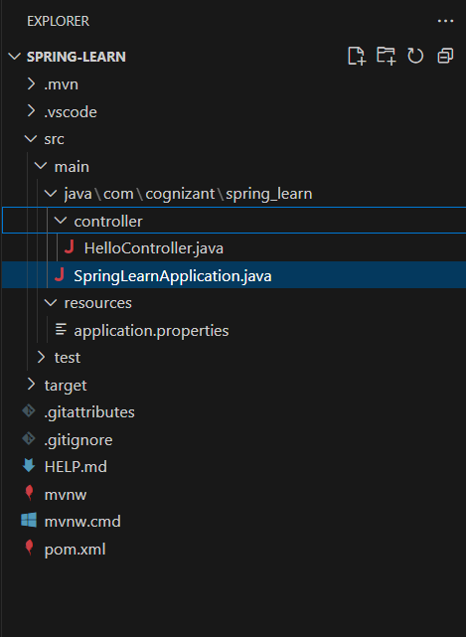

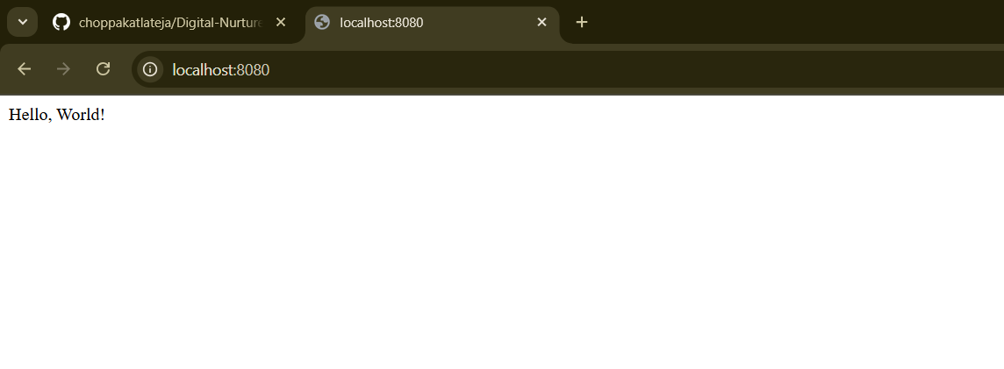

HelloController.java

package com.cognizant.spring_learn.controller;

import org.slf4j.Logger;

import org.slf4j.LoggerFactory;

import org.springframework.web.bind.annotation.GetMapping;

import org.springframework.web.bind.annotation.RestController;

@RestController

public class HelloController {

    private static final Logger logger = LoggerFactory.getLogger(HelloController.class);

    @GetMapping("/")

    public String sayHello() {

        logger.info("Start of sayHello()");

        String response = "Hello, World!";

        logger.info("End of sayHello()");

        return response;

    }

}